Honorable Kevin Cotter

Speaker of the Michigan House of Representatives

164 Michigan State Capitol  
100 N. Capitol Avenue  
Lansing, MI 48933

July 13, 2015

Dear Speaker Cotter,

We are pleased that you and your colleagues in the House and Senate have made it a priority to find a solution to fix Michigan’s roads. We are encouraged by the progress thus far, as we all know that solving this problem is important to the future job growth and economic prosperity of this state.

However, we have serious concerns with using existing General Fund resources to improve Michigan’s infrastructure. Both the House and the Senate plans rely on the reprioritization of at least $700 million in income tax revenue for transportation. The Senate plan also includes a mechanism that would roll back the state’s income tax if General Fund revenue exceeds the rate of inflation. This could have a particularly hard-hitting effect when coming out of a recession because revenues could decline during the recession, but would then be capped at inflation during the recovery.

Relying on existing revenue, especially if overall future growth is effectively limited to the rate of inflation, has the potential to significantly hinder investment in other areas of the budget, such as local government, higher education, public safety, public health services and economic development, all which rely on General Fund dollars. These areas have historically been the most susceptible to cuts during difficult fiscal times.

Finding ways to cut at least $700 million out of the state’s $10 billion General Fund is a difficult enough task by itself. Within the state’s General Fund budget the federal Medicaid match is approaching $2.7 billion, the Corrections budget is approaching $2 billion, the maintenance of effort for the Temporary Assistance for Needy Families is more than $550 million and state debt service is more than $150 million. Should the Legislature continue with their historical trends of not cutting these areas, finding $700 million in the remaining available General Fund budget becomes exceedingly difficult.

Rather than just managing the current crisis involving state transportation funding, we should be creating policy that ensures long-term sustainability and investment in all areas that are critical to the health, public safety, attraction and retention of talent and other areas that benefit Michigan job providers and residents.

We stand willing and able to work with you and your colleagues on a reasonable solution. As the economy continues to strengthen and grow, we should use that to our advantage and reinvest those returns into local government, higher education, public safety, public health services, economic development and other priorities, not limit our opportunity to invest in areas that are critical to developing the talent Michigan needs to compete. We urge you to work toward a common plan that does not fix one problem by creating others.

Sincerely,

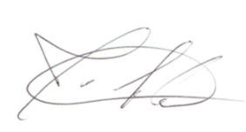 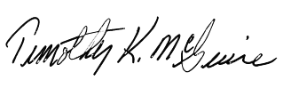

Joe Adams Timothy K. McGuire

State President Executive Director

Michigan Fraternal Order of Police Michigan Association of Counties

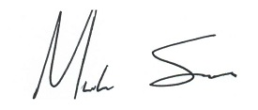 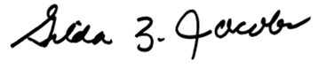

Michael Sauger Gilda Z. Jacobs

Vice President President & CEO

Michigan Association of Police Organizations Michigan League for Public Policy

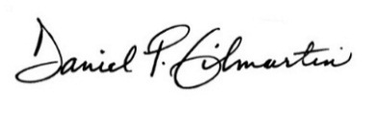 **D**

Daniel P. Gilmartin Mark Docherty

Executive Director & CEO President

Michigan Municipal League Michigan Professional Fire Fighters Union

C:\Users\jlamacchia\AppData\Local\Microsoft\Windows\Temporary Internet Files\Content.Outlook\FAAHMZNX\LMerrill-sig (00000002).tif 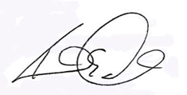

Larry Merrill Kenneth E. Grabowski

Executive Director Legislative Director

Michigan Townships Association Police Officers Association of Michigan



Daniel J. Hurley

CEO

Presidents Council, State Universities of Michigan